The Creation of a Movie Profitability Database

1: Introduction

We like movies! While this is true for most people, what factors actually lead to the average person cracking open their wallets and dropping their hard-earned cash on a movie ticket? Is this determined by genre? Is the MPAA rating a factor? What about the critical reaction to the film? What choices can producers make when deciding what movies to produce to maximize their profits at both the domestic and worldwide box office? Using data cribbed from Box Office Mojo, and Metacritic, we created a database that can be used to determine what factors to lead to the highest chance of profitability.

2: Methodology

In this project, we focused on extracting data, transforming it for ease of use and clarity, and loading it into a database for future use. We pulled data from two separate CSV files from Kaggle. One of these CSV’s was focused on data from the website Box Office Mojo. Using Pandas and JupyterLab, we cleaned this table down to Movie Title, Movie Year, Budget, Domestic Revenue, International Revenue, Worldwide Revenue, MPAA Rating, Runtime, and Genre.

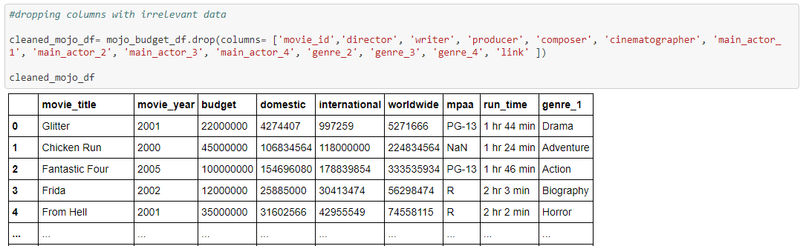

Using these same tools, our second CSV, which pulled data from Metacritic, was cleaned down to Movie Title, Metacritic Mixed, Metacritic Negative, Metacritic Positive, Metascore, User Mixed, User Negative, User Positive, and Userscore.

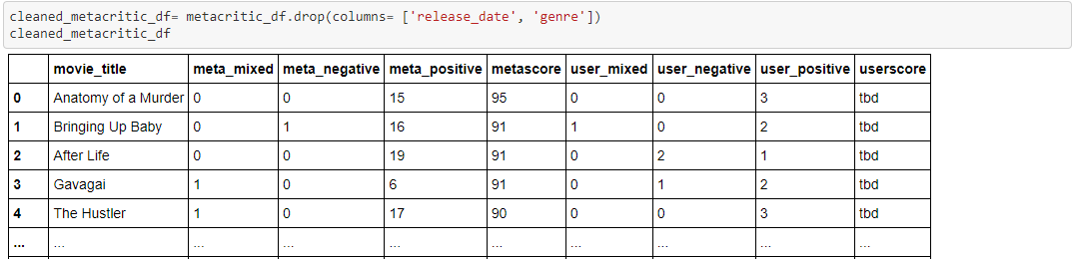

From there, we merged the two CSVs using a Left Join on Movie Title.

In order to deal with the Null Values in the final DataFrame, we first replaced any value of “TBD” with NAN.

Then we had to recast several variables as float, so we could replace those NAN values with a mean value.

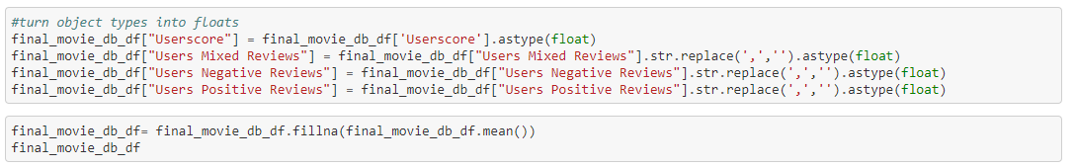

From there we used SQLAlchemy to create a SQLite database for our data.

- Assumptions
- PG-13 movies and action genre will be the most profitable, mostly because of the superhero movies

- Limitations
- Only US films between 2006-2016

3: Results

As we completed this ETL project we were able to complete some small initial data analysis. We performed a .describe function on the data and received the following results:

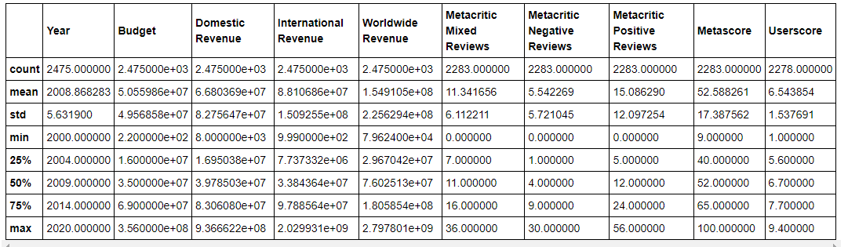

Also, pictured here is an image of the final database running in Visual Studio Code:

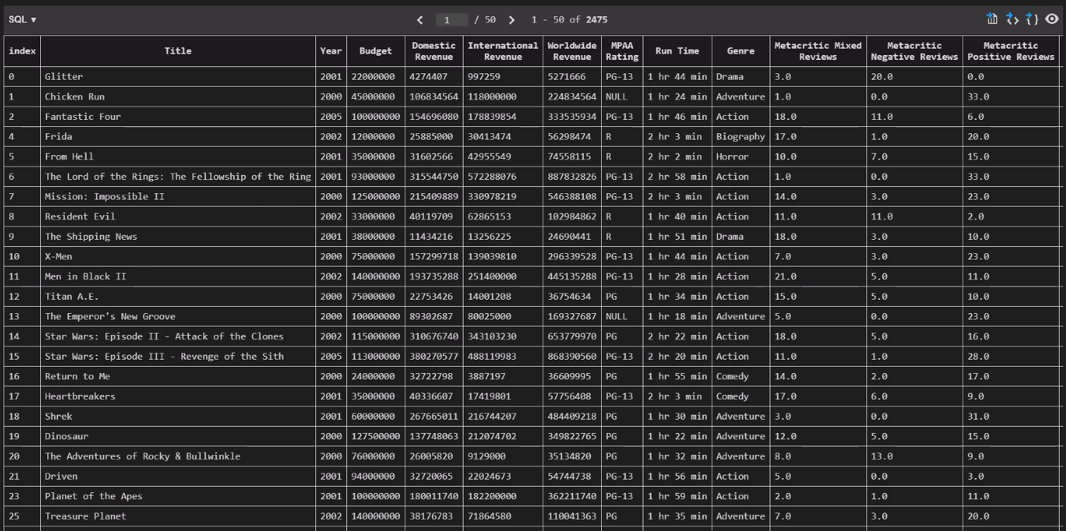

And as an example of the types of analysis that can be performed with this data, here is a histogram comparing MPAA Rating and Worldwide Revenue:

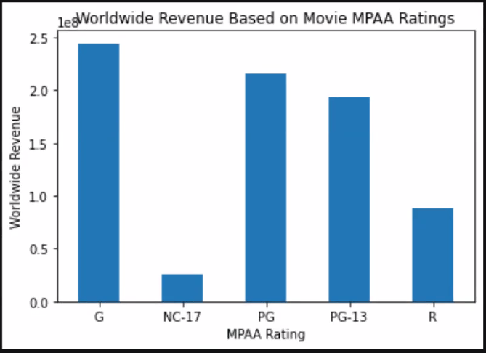

4: Conclusions

When all is said and done, we have created a database that will allow for a wide variety of data analysis. We can look at how revenue, both Domestic and International, is affected by Genre, MPAA Rating, and Critical and Audience reaction. The tools we used were beneficial in a variety of ways. Pandas, JupyterLab, and Visual Studio Code were crucial to our cleaning efforts, and allowed us to create the SQLite database we wanted. SQLite was valuable as it gave us the ability to have a database that lived directly on our Repository and could be shared around easily.

5: Recommendations

Assuming more time and resources were granted for continued improvements to this database, there are a couple of factors that would be worth investigating. First of all, some additional sources of critical and audience response should be collected. Scraping data from both IMDB and Rotten Tomatoes on both critical and audience scores would be valuable. This database also has a limited range of years that it includes, so scraping for movies from other decades on the sites already used would be a significant addition to the efficacy of this database.

References

https://www.kaggle.com/miazhx/metacritic-movie-reviews

https://www.kaggle.com/igorkirko/wwwboxofficemojocom-movies-with-budget-listed

https://towardsdatascience.com/how-to-deal-with-missing-data-in-python-1f74a9112d93

https://www.fullstackpython.com/blog/export-pandas-dataframes-sqlite-sqlalchemy.html

